15th. INTERNATIONAL CONFERENCE ON PHILOSOPHICAL PRACTICE
Philosophical practice to create humanizing relationships and peace contexts

GENERAL INFORMATION
What are the ICPPs?
ICPPs are the largest International Conferences in the field of philosophical practice. Since 1994, have concentrated the most important practical and applied philosophers of the international sphere such as Lou Marinoff, Gerd Achembach, Ran Lahav, Neri Polastri, Karin Murris, Oscar Brenifier, Ora Gruengard, Peter Raabe, Peter Harteloh, Anders Lindseth, Leon de Haas, Lydia Amir, José Barrientos, Roxana Kreimer (among other important philosophical practitioners), addressing the most diverse fields of application such as philosophical counseling, philosophy for children and young, philosophical workshops applied in various areas, philosophical cafes, philosophy for organizations, etc.

Philosophical practice responds to a fundamental concern: the need for philosophical applications and the need for philosophy on the part of society. Thus, since 70's and 80's of the past century, great exponents in this area have claimed that the work of philosophy has to do with approaching individuals, groups and organizations. This way, many methodologies, theoretical basis and materials have been constructed in order to emphasize that philosophy must be linked to an educational, interactive and applied task.

History of the ICPPS
In 1994, the first International Conference of Philosophical Practice was held in Vancouver, and since then the ICPP has been developed every year or two in different parts of the world. Countries such as Canada, Spain, Germany, Netherlands, USA, UK, Denmark, South Korea, Greece, Serbia, Switzerland, Italy, etc. have hosted this Conferences. This year is a source of great pride because we are facing the first International Conference of Philosophical Practice to be held in Latin America in 2018, specifically in Mexico.

PURPOSE AND FRAME OF THE EVENT
GENERAL OBJECTIVE
To promote the academic, educational and personal development of our assistants through the exchange and presentation of conferences, workshops, activities, panels and presentations of practical philosophers all over the world.

INVITING INSTITUTIONS
El Centro Educativo para la Creación Autónoma en Prácticas Filosóficas (CECAPFI) en conjunto con la Universidad Nacional Autónoma de México (UNAM), el Colegio de Ciencias y Humanidades (CCH), el Centro Latinoamericano de Filosofía Para Niños (CELAFIN), la Universidad Vasco de Quiroga (UVAQ), la Federación Mexicana de Filosofía Para Niños, el Observatorio Filosófico de México, el Centro de Cooperación Regional para la Educación de Adultos en Latinoamérica y el Caribe (CREFAL), Roma 3 University de Italia, la American Philosophical Practitioners Association (APPA), Departamento de Didácticas Específicas de la Universidad Autónoma de Madrid, España (UAM), la Facultad de Filosofía y Letras de la Universidad de Chile, el Instituto Salesiano de Estudios Superiores de México (ISES), el Centro de Filosofía Para Niños Newland, el Centro de Documentación en Filosofía Latinoamericana e Ibérica de México (CEFILIBE), el Instituto de Prácticas Filosóficas de Francia (IPP), el Grupo el Pensadero de Argentina, el Proyecto de Práctica filosófica Búho Rojo, el Café Filosófico Búho Rojo de Perú, Philo-Practice Agora de EEUU, el International Research program Wisdom (W3P), la Revista Internacional de Práctica Filosófica Haser, el Centro de Estudios e Investigación en Filosofía Francesa de Rosario, Argentina (CIFRA), la Editorial Novedades Educativas de Argentina, el Instituto de Filosofía Guadalaja, México (IF), Dramatic Philosophy de Australia, Café Filosófico de Esther Charabati de México, la Hellenic Society for Philosophical Practice de Grecia, Consulenza Filosofica de Italia (SUCF), la Korean Society of Philosophical Practice, la Soka Gakkai de México y la Asociación Filosófica del Uruguay (AFU).

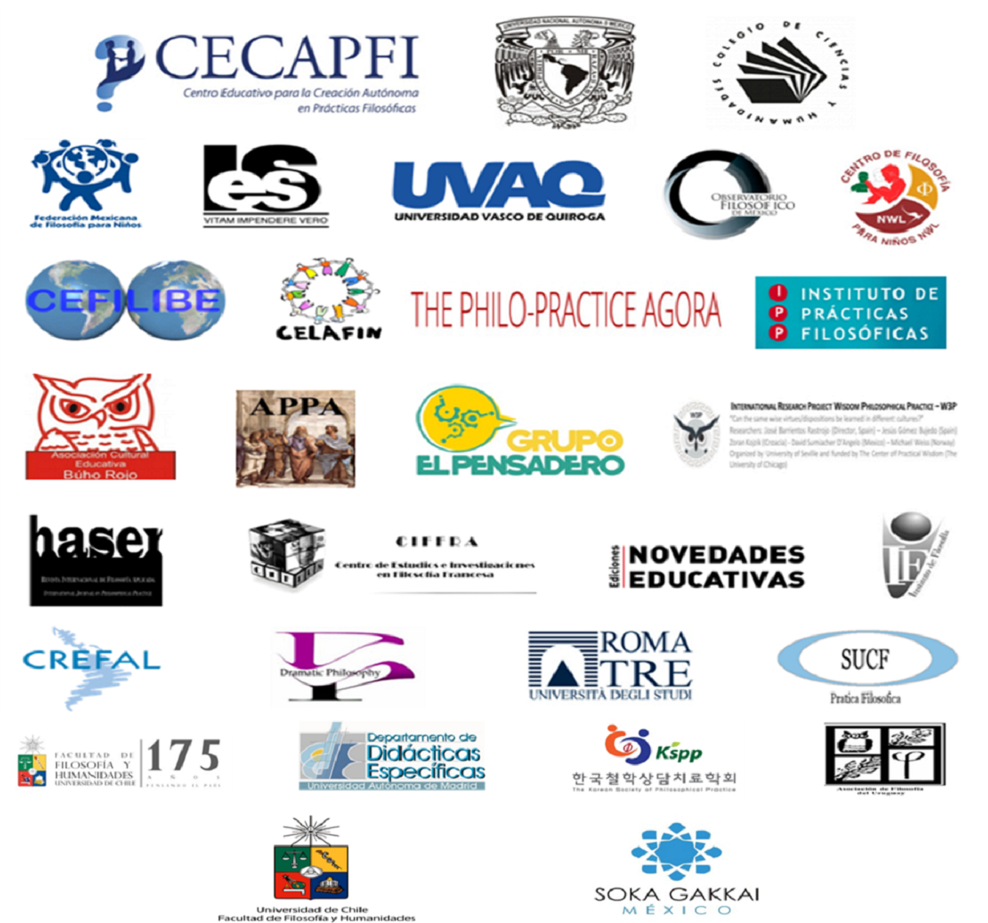

ACADEMIC COMMITTEE
Gerd Achembach (Germany), Lou Marinoff (USA), Ran Lahav (Israel), Peter Raabe (Canada), Peter Harteloh (Netherlands), Anders Lindseth (Norway), Young Rhee (South Korea), Oscar Brenifier (France), Detlef Saude (Switzerland), Leon de Haas (Netherlands), David Sumiacher (Mexico-Argentina), Tetsuya Kono (Japan), Jorge Humberto Dias (Portugal), Mike Roth (Germany), José Barrientos Rastrojo (Spain), Walter Kohan (Brazil), Mónica Cavallé (Spain), Lucie Antoniol (Belgium), Guro Hansen Helskog (Norway), Félix García Moriyón (Spain), Paulina Ramírez (Mexico), Miguel Angel Zapotitla (Mexico), Virginia Sánchez (Mexico), Ángel Alonso (Mexico), Carmen Zavala (Perú), Neri Polastri (Italy), Riella Moryahim (Israel), Michael Noah Wiess (Norway), Víctor Rojas (Colombia), Lydia Amir (Israel), Ora Gruendard (Israel), Soraya Tonsich (Argentina), Enrique Rendón (Mexico), Viktoria Cherneko (Russia), Leslie Cázares (Mexico), Alexsandar Fatic (Serbia), Angélica Enríquez (Mexico), Eugenio Echeverría (Mexico), Ricardo Cano (Mexico), Enrique Maraver (Mexico), José Ezcurdia (Mexico), Paola Zamora (Mexico), Narelle Arcidiacono (Australia), Julián Macías (Argentina), Olga Grau (Chile), Giancarlo Marinelli (Italy), Mauricio Langón (Uruguay), Víctor Florencio Ramírez (Mexico), Constantinos Athanasopoulos (Greece), Josefina Díaz (Mexico), Eloísa González (Mexico), Samuel Guerra Bravo (Ecuador), Víctor Hugo Galván (Mexico), Raúl Trejo (Mexico), Esther Charabati (Mexico), Mercedes García Márquez (España).

CALL FOR PAPERS

Types of participations
- Workshop
- Interactive theoretical presentation
- Book presentation
- Philosophical Poster

Thematic lines:
- History of philosophy and its relation to philosophical practice.
- Reflections on philosophical practice as an epistemic discipline (understanding of the discipline, ethical framework of philosophical practice, etc.)
- Philosophical counseling
- Workshops and applications with diverse groups (women, vulnerable groups, hospital patients, army, etc.)
- Philosophy for/with children
- Philosophy with organizations
- Didactics of Philosophy
- New challenges of philosophical practice
- Philosophical practice in education
- Philosophy in public spaces

Fill out your Registration Form (available at the end of this call) and send it to contacto@cecapfi.com before
March 31, 2018

All submissions will be reviewed by our Academic Committee which will provide support and guidance to our speakers.

DATE, PLACE, SEAT AND COST

Date: June 25-29, 2018
City: Mexico City, Mexico
Seat: National Autonomous University of Mexico (UNAM) (www.unam.mx )

Directed to: Philosophers, educators, psychologists, teachers, coordinators, leaders, entrepreneurs, lawyers, doctors, engineers, general public.

Costs:
- Mexico, Latin America, Africa, countries of emerging economies: $1,200 mxn (From 1 October to 28 February 2018). Then the cost will increase to $ 1,400 mxn from March 2018.

- Europe, USA, Canada, Japan, South Korea, Israel, Taiwan, Singapore, Australia: $110 usd (From 1 October to 28 February 2018). Then the cost will increase to $120 usd from March 2018.

The cost includes:
- Welcome and closing dinner
- Materials and gifts per person
- Coffee break during the Conference
- Access to all Conference activities

Make your payment in either of the following ways:
- Deposit via PayPal to the account contacto@cecapfi.com covering the corresponding cost and adding $ 70 MXN or $ 6 USD to the total amount (this payment has a surcharge for Paypal's operating costs).

- Bank deposit: BBVA Bancomer in the name of Centro Educativo para la Creación Autónoma en Prácticas Filosóficas. Account 0195803950, CLABE 012420001958039509 BIC CODE/SWIFT BCMRMXMM, ABBA: 021000021.

Special Call: In this ICPP we will complete a list of Universities and Institutions of Higher Level Studies that impart some program, subject, postgraduate program or project in relation to philosophical practice. This will be published for sharing with the international community. At the moment we have a list of almost 60 Universities! We hope that those who have not yet submitted information will support us with this valuable contribution for the development of our discipline. At the end of this call you can download the format, please send it to contacto@cecapfi.com

We look forward to see you soon!

Organizing Committee

David Sumiacher
Paulina Ramírez
Miguel Ángel Zapotitla
Ángel Alonso
Virginia Sánchez

